EJERCICIOS DE REPASO PTI SEPTIEMBRE 2014 (VOCABULARY)
1 Complete the sentences with the words below.
pessimistic  funny  loyal  cheerful  sporty  shy  serious  optimistic
1. Jenny always thinks something is wrong. She’s very ………………… .
2. Dave always sees the good in everything. He’s ………………… .
3. Donna doesn’t talk to many people. She’s ………………… .
4. Brad and Andy love running. They’re ………………… .
5. Tom always smiles. He’s a ………………… person.
6. You can’t ask for a better friend than Gina. She’s very ………………… .
7. Dan never laughs. He’s very ………………… .
8. Chloe always tells jokes. She’s very ………………… .
2 Circle the correct answer.

1. I don’t like to admit / refuse I’m wrong.
2. Don’t lie / hope. It’s better to tell the truth.
3. My parents want to expect / convince me to go with them.
4. Be careful. Lori likes to reveal / trick you into doing strange things.
5. Donna suspects / wonders we are planning a surprise party for her.
3 Find eight adjectives connected to music in the puzzle and write them below.
i | n | s | t | r | u | m | e | n | t | a | l
t | u | n | u | h | e | l | e | s | s | l | o
o | u | d | n | y | c | o | n | t | e | m | u
p | o | p | e | t | l | i | v | e | l | y | d
r | h | y | l | h | t | h | o | l | c | m | a
l | o | d | e | m | i | o | c | u | s | d | r
a | m | a | s | i | x | l | a | c | g | e | n
t | l | e | s | c | l | o | l | r | r | y | n
c | o | n | t | e | m | p | o | r | a | r | y
p | m | e | l | o | d | i | o | u | s | n | m

1. ………………… 5. …………………
instrumental
2. ………………… 6. …………………
3. ………………… 7. …………………
4. ………………… 8. …………………

4 Complete the puzzle. Use the pictures below.
1  6  7  8  2  3  4  5  9  10 | ¹ b | u | i | l | d | e | ² r |  |  | ³ |  |  |  | Across
 |  |  |  |  |  |  |  |  |  |  |  |  |  | 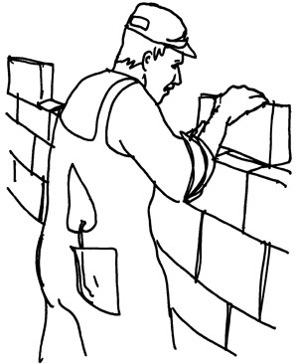 | 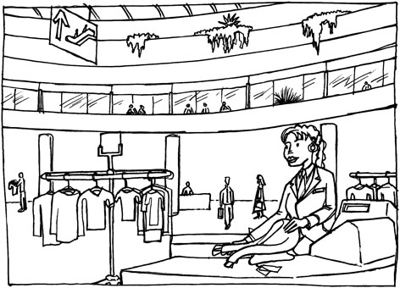 | 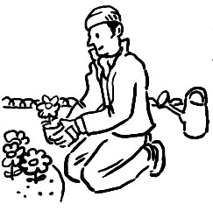 | 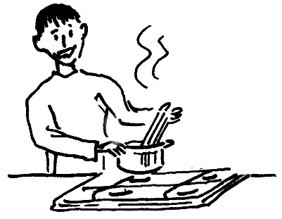
 |  | ⁴ |  |  |  |  |  |  |  |  |  | ⁵
⁶

 |  | ⁷
 |  |  |  |  |  |  |  |  |  |  |  |  |  | Down
 |  |  |  | ⁸ |  |  |  |  |  |  |  |  |  |  | 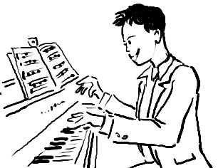 | 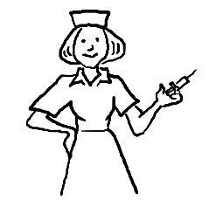
⁹

 |  |  |  |  |  |  |  |  |  |  |  |  |  | 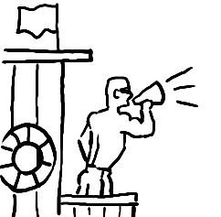 | 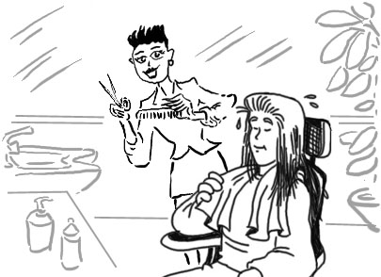 | 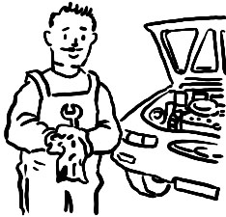
 |  |  |  | ¹⁰

5 Write the shapes. Find the hidden word.
1
2
3
4
5
6
 | 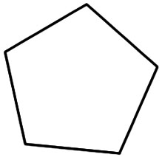 | 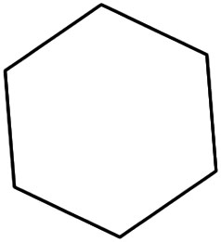 | 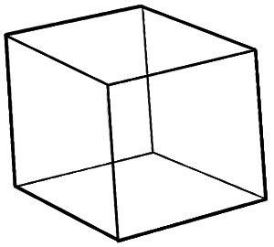 | 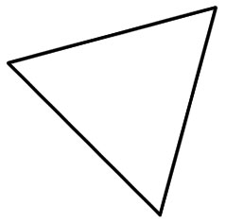 | 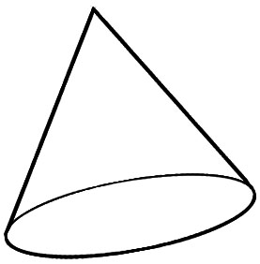

1.  s q u a r e |  |  |  | __ | __ | __ | __ | __ | __
2. |  |  |  | __ | __ | __ | __ | __ | __ | __ | __
3. |  |  |  | __ | __ | __ | __ | __ | __ | __
4. | __ | __ | __ | __
5. |  |  | __ | __ | __ | __ | __ | __ | __ | __
6. | __ | __ | __ | __

The hidden word is ………………… .
6 Circle six words. Then use the words to complete the sentences below.
incinginappropriatepowerful
shockingupbeatoriginalconv

1. We couldn’t believe the news about the car accident. It was ………………… .
shocking
2. Mary’s skirt it very short. I think it’s ………………… for school.
3. You’ll have to be more ………………… if you want me to believe you.
4. That’s an ………………… painting, not a copy.
5. I think films are often a lot more ………………… than books.
6. People should try to think positive thoughts and be ………………… .
7 Complete the sentences with the words below.
beach umbrella  sandcastles  thunderstorm  seashells  mineral water  food stand
mineral water
1. It’s very healthy to drink ……………………… .
2. I’m going to buy a sandwich. Do you want anything from the……………………… ?
3. When I was young, I loved building ……………………… at the beach.
4. We should go home. It looks like there will be a ……………………… soon.
5. It’s very sunny today. Put up the ……………………… .
6. My sister collects ……………………… and makes necklaces from them.
8 Look at the pictures and circle the correct answer below.
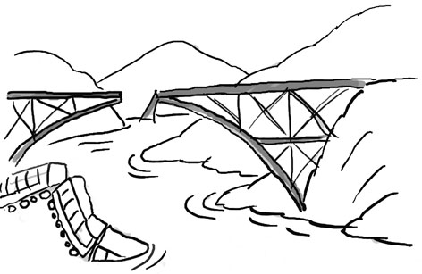  1  2  3  4  5  6  Not again! |  | 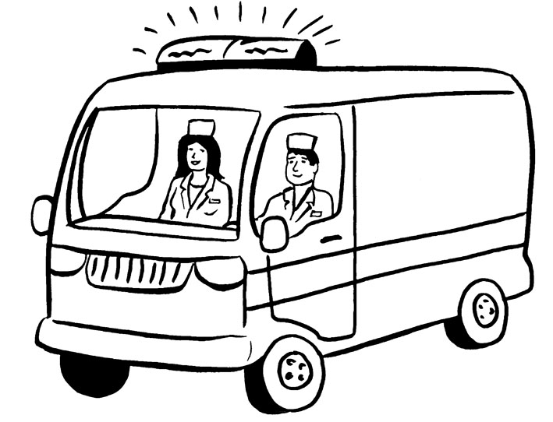 |  | 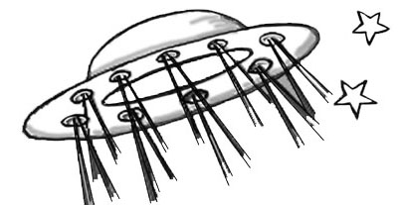
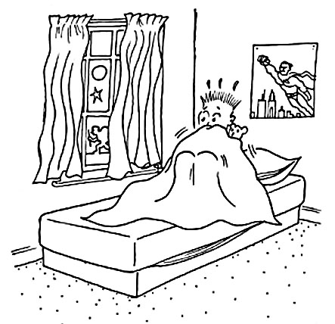 |  | 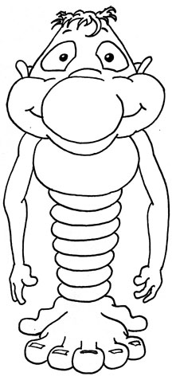 |  | 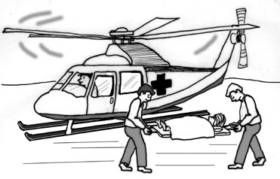

1. hurricane / bridge collapse / drought
2. bizarre occurrence / volcanic eruption / flashing lights
3. UFO sighting / global warming / earthquake
4. recurring nightmare / deforestation / disappearances
5. weird noise / strange creature / power failure
6. investigate / rescue / drown
9 Complete the puzzle. Use the clues. Find the hidden word.
1. The actors in a film are the …… .
2. I hate …… films because I get scared.
3. A make-up …… puts actors’ make-up on.
4. There is some beautiful …… in this film – lots of lakes and mountains.
5. A …… writes the words of a film in different languages.
6. The …… designer designs the clothes the actors wear.
7. The film includes many …… of the castle.
8. The …… crew films the film.
9. The …… tells the actors what to do.

1.  c a s t |  |  |  |  |  |  |  | __ | __ | __ | __
2. |  |  |  |  |  |  |  | __ | __ | __ | __ | __ | __
3. |  |  |  |  |  |  |  | __ | __ | __ | __ | __ | __
4. |  |  | __ | __ | __ | __ | __ | __ | __
5. |  | __ | __ | __ | __ | __ | __ | __ | __ | __ | __
6. |  |  |  |  |  |  |  | __ | __ | __ | __ | __ | __ | __
7. |  |  |  |  | __ | __ | __ | __ | __
8. |  |  |  |  | __ | __ | __ | __ | __ | __
9. | __ | __ | __ | __ | __ | __ | __ | __

The hidden word is ………………… .

