EJERCICIOS PTI 2ª EVALUACIÓN 4ºESO
1 Choose the correct answer.
1. I will go / go / don’t go to the party if I finish my homework on time.
2. Unless we will record / record / don’t record this information, we will forget about it one day.
3. Nobody will find this time capsule if you will hide / hides / hide it here.
4. Will he perform if it will rain / rains / rain tonight?
5. If you read The Time Machine, you enjoy / don’t enjoy / will enjoy it.
2 Write the sentences with the words below. Use the First Conditional.
1. you / be / invisible / if / you / wear / this cloak

2. everyone / know / your secret / if / you / tell / Jane

3. unless / we / catch / the AVE / we / not arrive / on time

4. if / a hurricane / hit / this island / there / be / many victims

5. I / not speak / to Steve / if / he / not apologise

3 Complete the sentences with the verbs in brackets. Use the Second Conditional.
1. If I …………………… (have) more time, I …………………… (stay).
2. I …………………… (fix) it if I …………………… (understand) the problem.
3. I …………………… (can) answer the question if I …………………… (not be) so tired.
4. If I …………………… (know) the answer, I …………………… (tell) you.
5. If I …………………… (be) taller, I …………………… (reach) it.
4 Complete the sentences with the verbs in brackets. Use will.
1. I think Donna ……………………… (be) a famous guitarist in the future.
will be
2. Ryan ……………………… (win) the competition next week.
3. Scientists ……………………… (not invent) a flying car next year.
4. It’s very hot. I ……………………… (take) my sun hat.
5. The teacher ……………………… (not allow) us to leave early.
6. The music is too loud. My parents ……………………… (complain).
5 Write questions with the words below. Use will.
1. rap music / be / popular / in 2050
Will rap music be popular in 2050?
2. everyone / speak / Spanish / in the future

3. computers / write / music / one day

4. CDs / be / cheaper / next year

5. musicians / play / more jazz / in the future

6 Predict the future. Answer the questions in Exercise 3.
1.
2.
3.
4.
5.
7 Complete the sentences with the verbs in brackets. Use be going to.
1. The family …………………………… (have) dinner soon.
is going to have
2. The musicians …………………………… (play) some music later.
3. Donna …………………………… (not buy) a new dress next week.
4. The children …………………………… (study) French tomorrow.
5. The baby …………………………… (go) to sleep soon.
6. We …………………………… (not watch) the DVD tonight.

8 Complete the chart.
Adjective | Comparative | Superlative
1. big | bigger than | the biggest
2. pretty
3. comfortable
4. good
5. trendy
6. popular
7. bad
8. thin

9 What do you think? Tick T (true) or F (false).
T F
1. English is more difficult than Spanish.

2. Physics is the easiest subject at school.
3. Milk is the healthiest drink in the world.
4. Tennis is the best hobby.
5. Madrid is more beautiful than Seville.

10 Complete the sentences with the comparative or superlative form of the adjectives in brackets.
1. The T-shirts are ……………………… (cheap) the dresses.
cheaper than
2. Brad is ……………………… (tall) of all the teenagers.
3. Suzy’s dress is ……………………… (pretty) Gina’s dress.
4. Trendy Boutique is ……………………… (fashionable) Freda’s Fashions.
5. Gina is ……………………… (happy) Suzy.
6. The red dress is ……………………… (expensive) dress in the shop.

11 Look at the pictures. Then choose the correct adjective to complete the sentences below. Use the comparative.
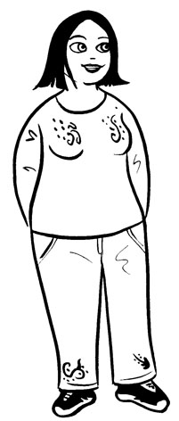  Megan  Tracy  Alice | 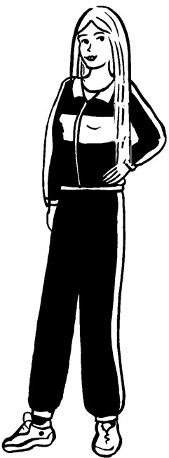 | 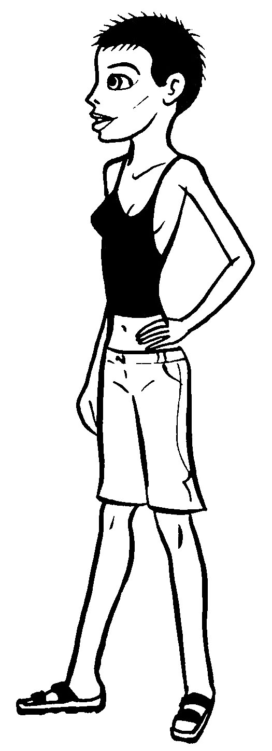

1. Megan is ……………………… Alice. (tall / short)
taller than
2. Tracy’s hair is ……………………… Megan’s. (long / short)
3. Tracy is ……………………… Megan. (thin / fat)
4. Alice’s hair is ……………………… Tracy’s. (long / short)
5. Megan is ……………………… Tracy. (fat / thin)
12 Look at the pictures in Exercise 4 again. Then complete the sentences with the superlative form of the adjectives below.
tall long short fat thin
1. Alice is ……………………… girl.
the thinnest
2. Tracy is ……………………… girl.
3. Alice has got ……………………… hair.
4. Tracy has got ……………………… hair.
5. Megan is ……………………… girl.

